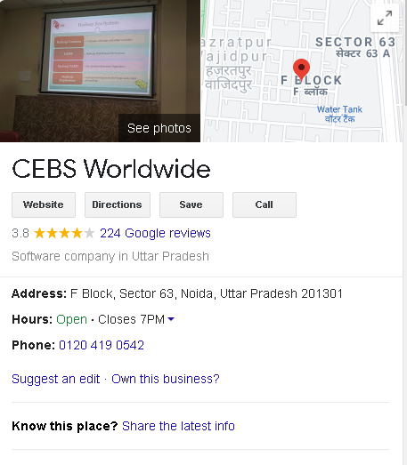



**GOOGLE:**

REPORT OF CEBS

Rating: 3.8 star

Google reviews: 38

Total Month Reviews Updated: 38



**CEBS**

**WORLDWIDE**

May 10th to

April 10th, 2021



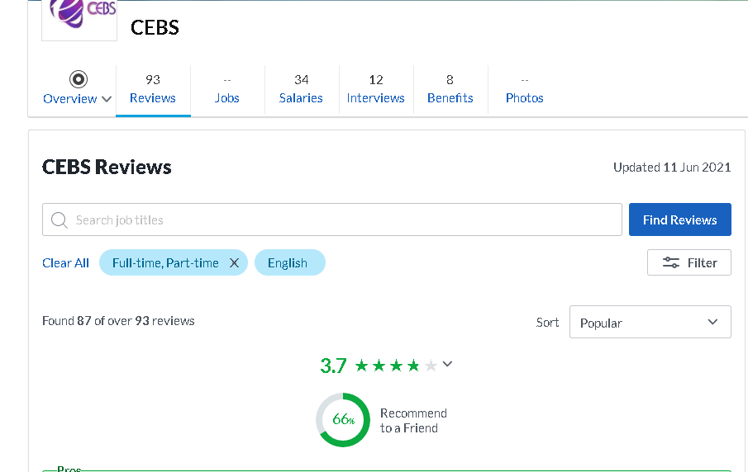



**GLASSDOOR:**

REPORT OF CEBS

Rating: 3.7 star

Glassdoor reviews: 18

Total Month Reviews Updated : 18



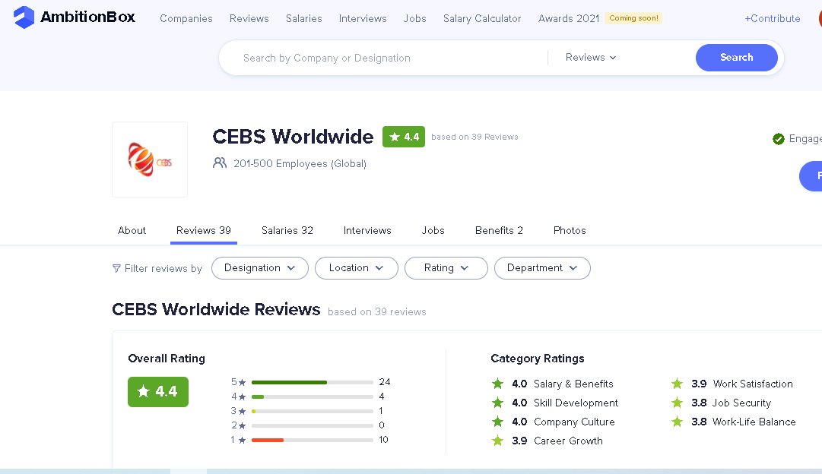



**AMBITIONBOX:**

REPORT OF CEBS

Rating: 4.4 star

Total Month Reviews Updated: 04

Total Reviews: 39



•



**INDEED:**

REPORT OF CEBS



Rating:

05

star

Total Month Reviews Updated: 04

Total Reviews: 14

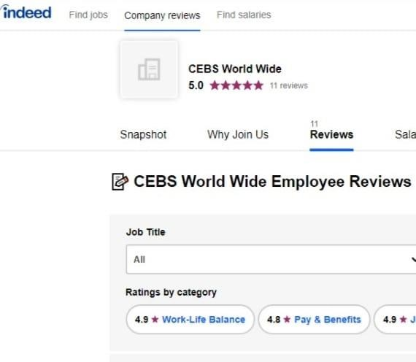

Rating:

4.8

star

Total Month Reviews Updated: 05

Total Reviews: 12



**WHAT WE DID:**

**1. Reputation Monitoring:**

* Tracking online reputation of the business.



* Learn about your audience.
* Keyword based monitoring

# Review Content Research

* Research quality content
* Write review based on quality & keyword
* Write review based on Negative commenting

# Review management



* Onsite Feedback
* Integrated review solutions - Offsite reviews

# Damage Repair

* Dialogue control
* Negative review control